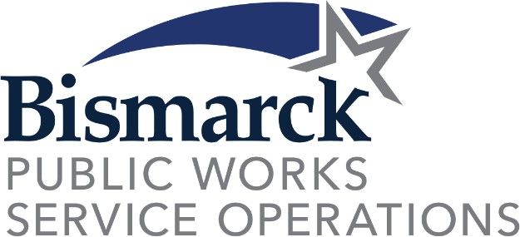
Forestry Advisory

Board

REGULAR MEETING AGENDA
January 21, 2025

Landfill East Conference Room
Public Works Building 12:15 PM

The regular meeting of the Forestry Advisory Board (FAB) is scheduled for Tuesday, January 21, 2025, at 12:15 PM in the Conference Room of the Public Works Building.

REGULAR AGENDA
- Approval of the minutes from the October 15, 2024 regular meeting of the FAB
- 2024 Recap - Staffing, DED, Pruning, Removals, Planting, PIP
- 2025 Outlook/Plans - Staffing, Work plans, Planting projects/grants, Contracts
- FAB member terms
- 2025 Arbor Day
- Other items

