- Getting Started: Be prepared before you log in

1.1 Know that

- Applicants should review the Site Plan Review Information Guide
- eTRAKiT will time out after 20 minutes of inactivity. If you time out, when you sign-in again click continue. You might have to re-enter information.
- Do not use the browser back button.
- Speak to the Engineering Department for storm water scoping sheet approval (PCSMP or SM-04) before applying for a site plan review or waiver request. The storm water plan review process is separate from the site plan review process.

1.2 Setup an Account

An AEC (Architect, Engineer, Contractor) registration is required to:
- Apply for a lot modification or site plan
- Pay by invoice - if you also request a BILL ME account
- View detailed information about your application.
Contact the Community Development Department – Planning Division in one of the following ways to request an AEC account and temporary password.
In Person City/County Office Building
2nd Floor | Community Development Department
221 North 5th Street
Bismarck, ND 58506-5503

By Phone (701) 355-1840

By Email planning@bismarcknd.gov

1.3 Payment

- If you want to be billed (receive an invoice) by the City of Bismarck you must first open an AEC and BILL ME account by contacting the Planning Division. eTRAKiT will otherwise accept VISA, MasterCard, and Discover card payments.

- The typical (non-inclusive) fee schedule for requesting a site plan review is outlined in the Site Plan Review Information Guide

These fees do not include storm water review fees, which are determined during the scoping process by the Engineering Department at 701.355.1505. The City may charge additional fees based on actual review time required by staff because of resubmittals, field conditions, complexity of projects or site plan revisions.

1.4 Submittal Requirements

    - Please review the following and contact the Planning Division prior to applying if you have any questions:

- First visit the Bismarck Property Search to verify your project address, parcel identification number and legal description. Call the Planning Division before you apply if an address does not appear.
- Please review the Site Plan Requirements document which includes a checklist of submittal requirements.

    - Prior to beginning your application, please have all the following required submittal items ready to upload electronically:

  - Complete pdf of the SITE PLAN including a LANDSCAPE plan if required.
  - Complete pdf of APPROVED SM-04 (PCSMP Scoping Sheet from Engineering.
  - Complete pdf of NARRATIVE statement of intentions.
2.0 How to Access eTRAKiT

2.1 The website address for eTRAKiT is https://trakitapi.bismarcknd.gov/etrakit/ You may also access eTRAKiT through the City of Bismarck homepage at www.bismarcknd.gov and click on the services link and the on-line Permits - eTRAKiT link.

3.0 Log In

3.1 Registered User Login (able to use BILL ME option upon approval by the Planning Division and having requested the Bill Me option).

3.1.1 Change login type to Registered Contractor/Developer/Builder. Choose company name from Username drop down list, and enter password provided for you when you registered.

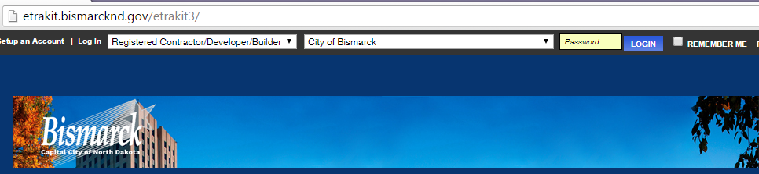

3.1.2 Click button and you will be directed to change your password (only the first time you login).
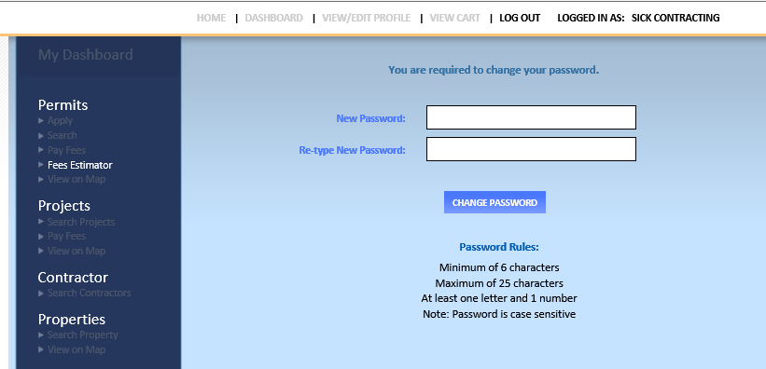
4.0 PROJECTS: To Submit a Site Plan for Review

4.1 Select Apply for New Project from the Menu in the left margin. You can only APPLY if you are a registered user. Please call the Planning Division if you would like an AEC account which allows you to see all reviews, comment electronically, and get timely emails regarding the status of your application.
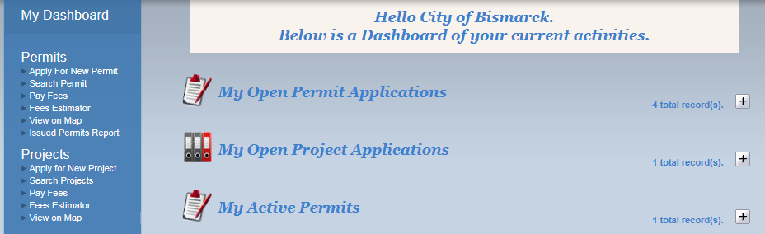
4.2 Check the box next to “I Agree” and then click Continue.
  - Step 1 Enter Project Information
4.3.1 Select Project Type and SubType from drop down menus.
4.3.2 Enter Project Name IN CAPS describing work to be completed.
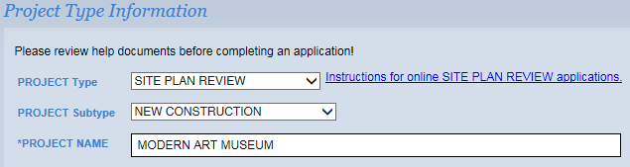
4.3.3 Enter information requested. All questions marked with an asterisk (*) must be answered.

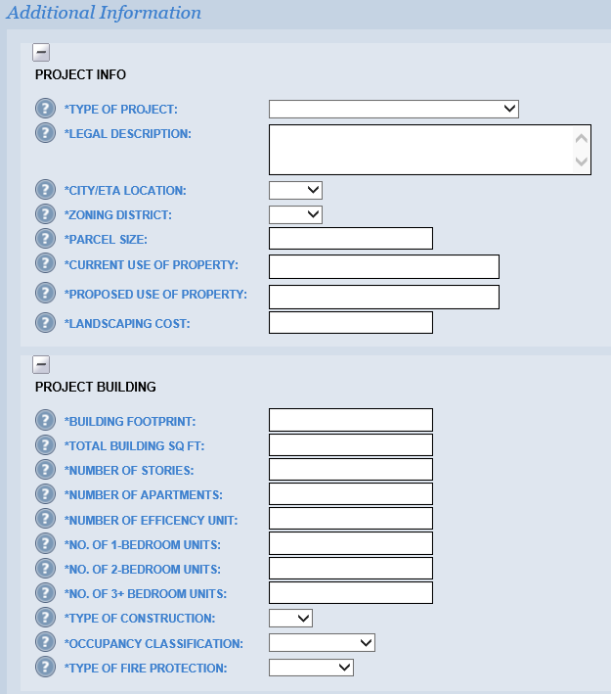
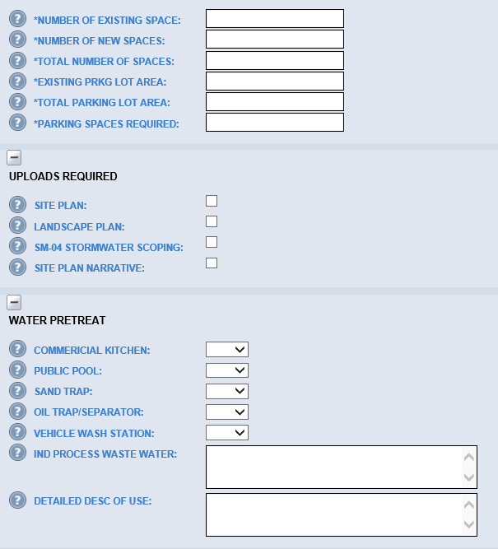

4.3.4 Enter a partial address and click Search. Then select the correct address for the site plan. You will only be able to select one address.

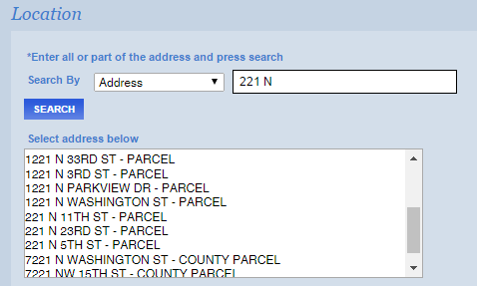

4.3.5 Check the next box if you are the property owner.

4.3.6 Upload the following 3 or 4 (three or four) Required Submittal Items (as stated in 1.4.2 above) as separate pdfs by clicking . Please use distinguishing file names.

  - Complete pdf of the SITE PLAN including a LANDSCAPE plan if required.
      - Please rename the file name of the attachment to SITE PLAN_[6DIGIT DATE] (use the date you are submitting the site plan)
      - If submitting separately please rename the file name of the attachment to LANDSCAPE PLAN_[6 DIGIT DATE] (use the date you are submitting the site plan)
  - Complete pdf of APPROVED SM-04 (PCSMP Scoping Sheet)
  - Complete pdf of NARRATIVE statement of intensions.
      - Please rename the file name of the attachment to NARRATIVE_[6 DIGIT DATE] (use the date you are submitting the site plan)
4.3.7 Click Upload.

4.3.8 Once the attachment has been uploaded, the file will be listed to the right, under the Attachments heading. The process may be repeated to add additional files. If the wrong file was uploaded, it may be deleted using the associated Delete button. You can also attach from a completed application (see 5.3 below). In order to delete an attachment once an application is submitted you must contact the Planning Division.

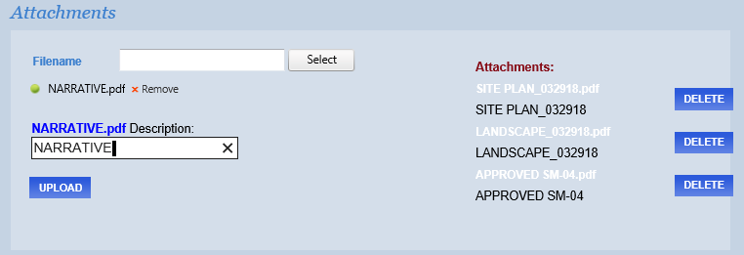

4.3.9 Click Next Step.

4.4 Step 2 Contact Information
4.4.1 Enter or confirm the Applicant, Consultant contact if necessary, and Owner information. Please update contact information if the incorrect email or address automatically populated fields. Then click Next Step. Project status changes to the requested site plan are sent via email, while approval letters are mailed to the street addresses you provide.
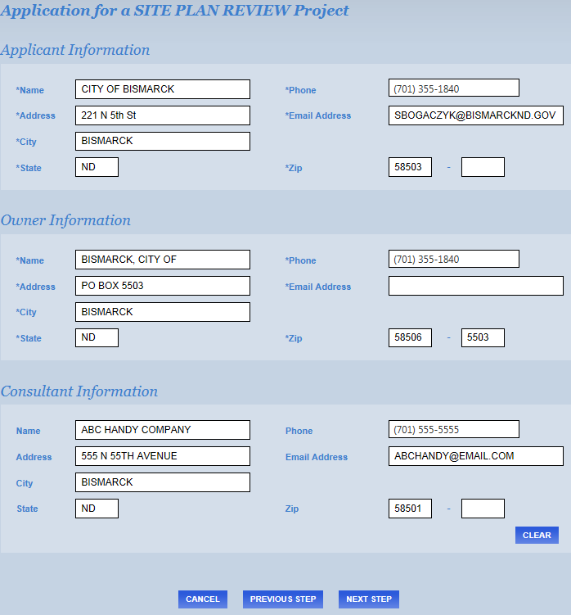
4.5 Step 3 Review and Submit
4.5.1 If everything is correct click Submit. Otherwise, click Previous Step to edit. (See 1.3)

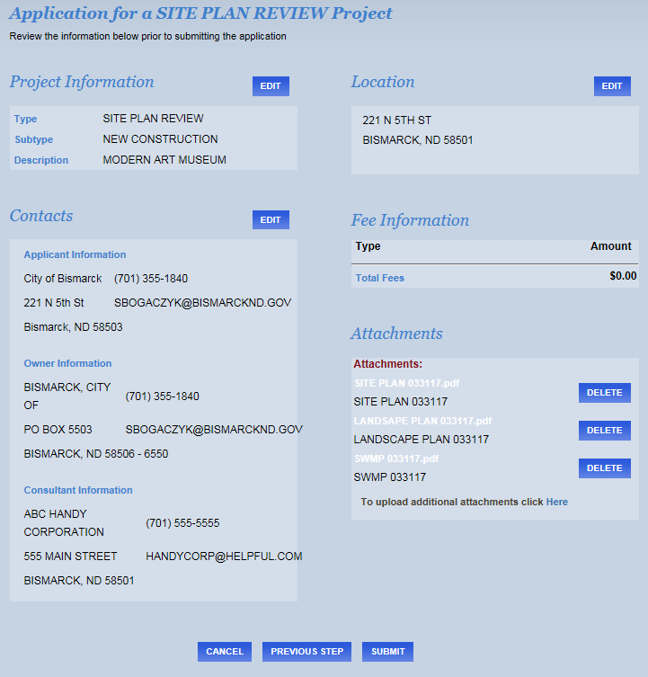

4.5.2 All Contacts with an email listed will receive an email confirming that the application has been submitted. A follow-up autoemail will be sent reporting your eTRAKiT status as either Incomplete, Payment is Requested or your site plan is In Review.
4.5.3 If you click View Project you will be able to see the review process, once a project has been paid, by clicking the tab Reviews.
  - Step 4 To Pay for a Site Plan Review
4.6.1 If you did not pay for your review when you applied, you will receive an autoemail requesting payment. Log into eTRAKiT and scroll to the project on your Dashboard under My Active Projects and click on one of the fees you wish to pay.
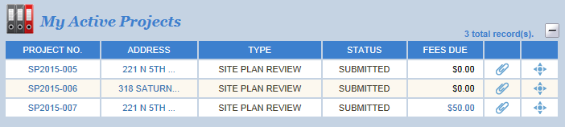
You can have a different person pay for fees using a credit card by having them create a Public User account and add the site plan project number to their dashboard to see a similar screen as above.
4.6.2 Review your shopping cart and select Proceed To Checkout. This will take you to your Checkout Summary.
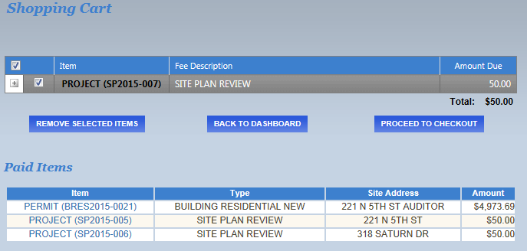
4.6.3 From the Checkout Summary select Proceed To Payment to pay using VISA, MasterCard, or Discover card. To use the BILL ME option and receive an invoice for prompt payment you must have already been approved to do so by the Planning Division, having previously requested an AEC account and BILL ME privileges. An invoice will be mailed to the Applicant’s mailing address listed in Contacts if BILL ME is chosen.
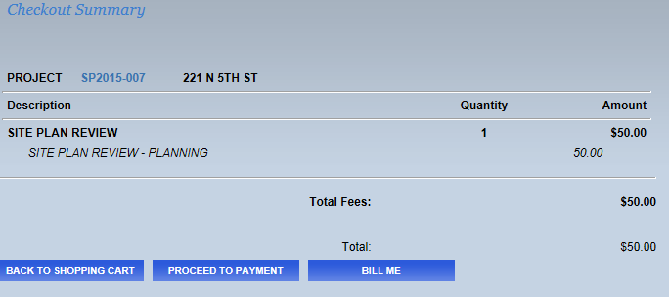
5.0 Site Plan REVIEW AND APPROVAL PROCESS

5.1 An email is sent (to contacts if an email is provided) when a status of Submitted, Incomplete, Payment Required, Paid, In Review and Approved is updated.
5.2 Upon receipt of a complete submittal, the initial review will occur. If site plan revisions are required, additional review time will also be required. The Applicant will be notified if more information is required to review the request via an email notification when the project is placed into Revise & Resubmit status.
5.3 As the site plan is reviewed, staff will provide review comments in TRAKiT. It is the responsibility of those listed as Contacts to monitor the comments made, and respond and/or make revisions to the site plan or storm water plan as required by logging into eTRAKiT. (See 5.2.1 below). An email is not automatically sent to Contacts every time a comment is submitted, only when a project status has changed from, for instance, Submitted to Payment Required. However, a summary of all review comments will be uploaded when all staff complete their initial and follow-up resubmittal reviews. An email to Reviewers is generated every time a Contact submits a comment to a Reviewer, or a pdf is attached.
5.3.1 To check reviews and the status of your application please login as seen in 3.0 using your user name and password. From My Dashboard scroll down to My Active Projects and click the project number.

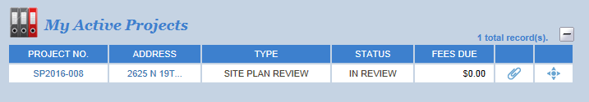

5.3.2 Click Reviews tab

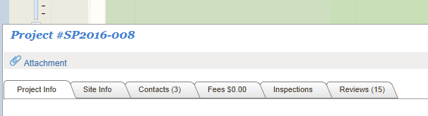

5.3.3 Click each Respond or More Info title to see reviewer comments, and scroll down for entire list.

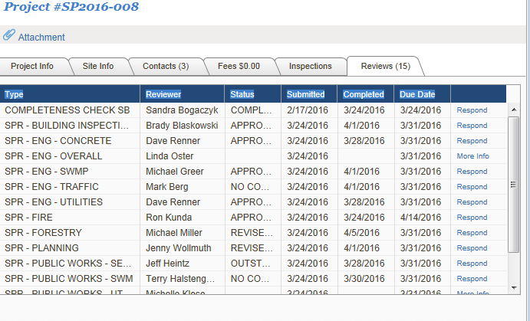

5.4 A report including all reviewer comments pertaining to the site plan will be generated after each round of reviews by Engineering (701) 355.1505 as long as new issues are addressed. This report will be uploaded to attachments and be named PROJECT REVIEWS W/CONTACTS_[6 DIGIT DATE].

5.5 Site plan approval letters will be issued by the Engineering Department by email to contacts and sent via USPS to the owner when all matters are resolved and all reviewers have approved the site plan. The approval letter will also be attached to eTRAKiT and can be viewed as any other attachment.

5.6 Once a project is Approved and then Closed by the Engineering Department you will no longer see it on your Dashboard. You can access the project and attachments, including approval letters, by:
- Logging in (See 3.0)
- Clicking Search Projects in the left column and typing an Address, Project #, or Project Type.

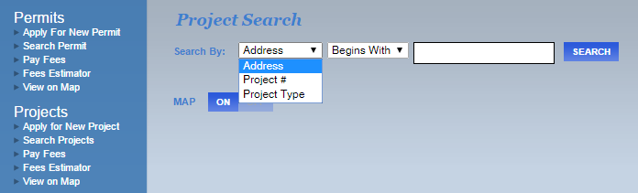

Thank you for your participation in our eTRAKiT online digital application process.

